**CS 6301.004: Assignment 3 (Image Classification)**

**Team Members:**

Prathyusha Kanmanth Reddy(pxk166230)

Teja Kiran Chunduri(txc163430)

Shree Charan Varma Enugandla(sxe170530)

Sneha Nandigala(sxn171430)

Srinivasa Rajesh Ayachitula(sxa172830)

**Image classification on Huskies and Tigers-cats**

In this assignment we will do an unsupervised learning on the Huskies and Tiger-cats’ data from image-net.

The following report focuses on the methods used for classifying Huskies and Tiger-cats dataset and gauging the performance by calculating the accuracy for different parameters.

Additionally, image is an object which needs to be studied pixel by pixel to get a through idea about which class it belongs to.

**Running in the GCloud**

We have faced several issues running the R code in the Google Cloud environment.

One of many is issue with the **EBImage** package that we have chosen to use for image related functionalities like reading an image, converting to greyscale and resizing.

**On analysing further, we came to the following conclusions:**

GCloud uses a package dependency system called ‘**packrat’** to install required libraries in the VM instance. EBImage however is installed from the ‘**BiocManager’** package and packrat is not able to find the correct URL to download the ‘BiocManager’ package, where it halts the execution.

We have even tried **sourcing** the package directly, but it is ignoring all the installation details but instead relying completely on packrat.

We’ve tried other packages as well like ‘**imager’** and ‘**magick’**. ‘imager’ is somehow dependant to ‘EBImage’ and so it’s failing for the same reason that EBImage is failing.

Also, with magick package we encountered the issue with packages. It’s a different issue altogether, wherein it says that ‘egrep’ installation is failing.

We then proceeded to run the classifier locally. No paths have been hardcoded. We are getting the data from UT Dallas public.

1. **Dataset**

Huskies and Tiger-cats dataset is a public set of images downloaded from image-net. The Huskies are labelled as 1 and Tiger-cats are labelled as 0.

1. **Results**

|  |  |  |
| --- | --- | --- |
| Iteration | Parameters | Train and Test Accuracy |
| 1 | Number of layers : **4**  Activation function : **sigmoid**  Kernel size : **5** | Train = 54%  Test = 51% |
| 2 | Number of layers : **4**  Activation function : **relu**  Kernel size : **5** | Train = 85%  Test = 72% |
| 3 | Number of layers : **3**  Activation function : **relu**  Kernel size : **5** | Train = 83%  Test = 71% |
| 4 | Number of layers : **5**  Activation function : **relu**  Kernel size : **3** | Train = 74%  Test = 71% |
| 5 | Number of layers : **4**  Activation function : **relu**  Kernel size : **3** | Train = 81%  Test = 73% |
|  |  |  |

**Interpreting the 5 x 5 image labelling:**

The image displayed in the grid is not the original image. It is the pre-processed version of the original image.

We’ve first converted the original image into grayscale image.

Then we resized the image to 28 x 28 pixels.

Each image has the following information: (Probability, Actual label, Predicted label)

If the classifier has predicted correctly then the probability and predicted label are displayed in green colour else, they are displayed in red colour.

We randomly picked 25 images from the test data set and displayed in the 5 x 5 grid as instructed.

The rest of the report contains the 5 x 5 image grid and History plot for each of the above 5 iterations mentioned in the results respectively.

1. **History plots and prediction images:**
2. Iteration 1

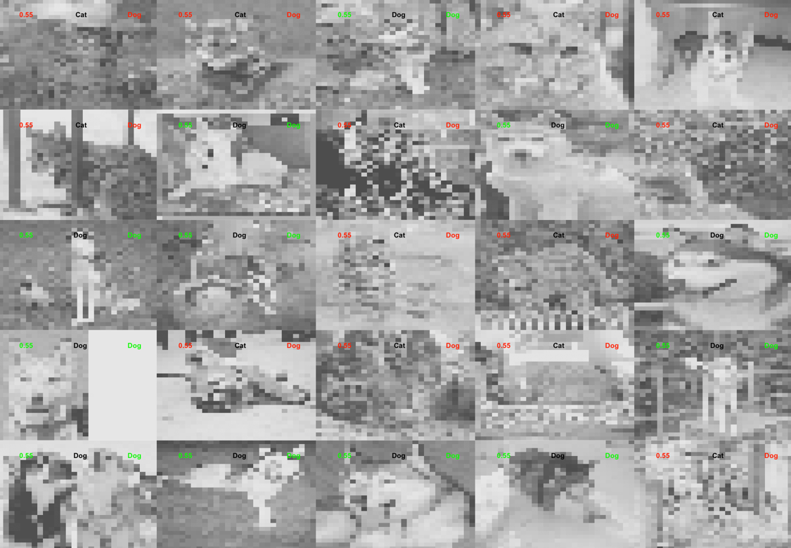

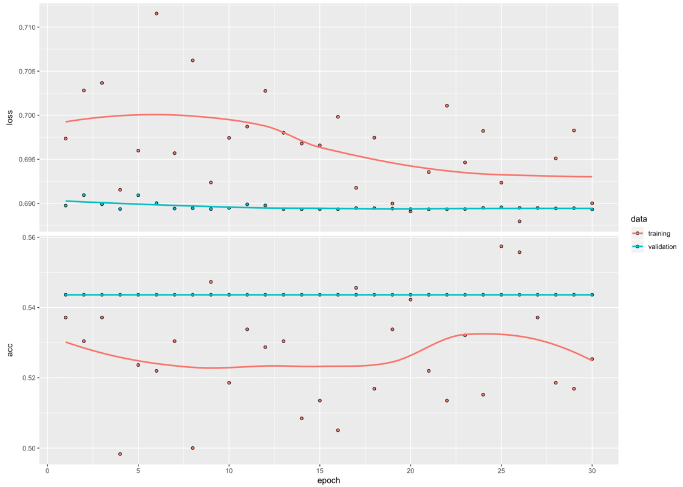

1. Iteration 2





1. Iteration 3



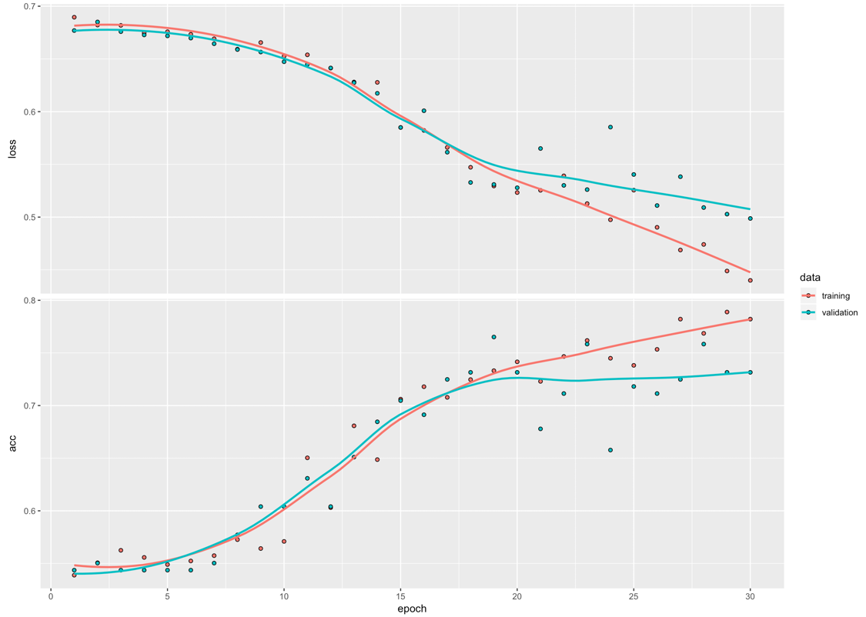

1. Iteration 4





1. Iteration 5

